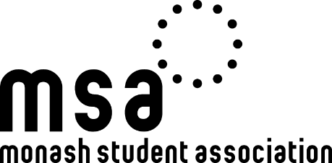

Monash Student Association (Clayton) Incorporated
2021 DISABILITIES AND CARERS COMMITTEE ANNUAL ELECTIONS
Monday 25 October – Thursday 28 October 2021
NOMINATION FORM

PLEASE ENSURE YOU WRITE NEATLY AND USE BLOCK LETTERS ONLY
By signing this form you give consent to the Returning Officer to verify your personal details with the University to ensure you are eligible to stand as a candidate and you agree to adhere to the rules of the election as set down by the Election Regulations, MSA Constitution and the directions of the Election staff.
Nominations close 5pm, Wednesday 20 October. Nominations must be signed by the candidate and submitted by email to the Returning Officer.
If you require assistance completing this form, please contact the Returning Officer on 0403 336 829.
CANDIDATE DETAILS
First Name: |  |  | Last Name:
Student ID: |  |  | Email Address:
Address:
Do you identify as having a disability or being a carer? (Y/N) (delete as appropriate)
Are you a member of the Disabilities & Carers Collective? (Y/N) (delete as appropriate)
Mobile Phone Number:
Position: |  | Disabilities & Carers Committee
Signature:

